ISTE240 Final Project Report

Spring 2026 Semester

ReelTalk: Movie Review Web App

Team 5
Amal Junaid (751008715),
Madheeha Sameen(764002947),
Mehrin Fathima (418006818),
Grishma Bhandari 761001853

PROJECT URL: https://github.com/amaljunaid2005/ISTE240-600-Team5.git

Rubric
FRONTEND (20 pts) – CLOS 2, 3 and 5
├── 18-20: Professional + Bootstrap + responsive + toasts + loading states
├── 14-17: Clean + responsive + basic response messages
├── 10-13: Basic CSS + not responsive
└── 0-9: No CSS or broken

REST API (25 pts) – CLOS 4 and 5
├── 22-25: Each student has own controller + All 6 methods
├── 17-21: Each has controller + 4-5 methods
├── 12-16: Only 1-2 controller + 2-3 methods
└── 0-11: Only one controller + Less than 2 methods

JPA (20 pts) – CLO 4
├── 17-20: Each student has own repository + 5+ methods + entity classes
├── 13-16: Each has repository + 3-4 methods
├── 9-12: Only 1-2 repository + 1-2 methods
└── 0-8: One repository for all → ZERO for section

GIT (10 pts) – CLO 1
├── 9-10: Branches + 5+ commits + good messages + PRs
├── 7-8: Branches + 3-4 commits
├── 5-6: One branch + 1-3 commits
└── 0-4: Single commit

DEMO (15 pts) – CLOS 2, 3 and 5
├── 13-15: 5+ pages + all CRUD + no errors
├── 10-12: 4-5 pages + most CRUD
├── 7-9: 3 pages + basic CRUD
└── 0-6: Less than 3 pages

FINAL REPORT (10 pts) – CLO 1
├── 9-10: Complete documentation + API docs + team contributions + screenshots
├── 7-8: Most sections present + basic API docs
├── 5-6: Basic report + missing key sections
└── 0-4: No report or very incomplete

FINAL PRESENTATION (10 pts) – CLO 1
├── 9-10: Clear explanation + live demo works + answers questions confidently
├── 7-8: Good presentation + minor demo issues
├── 5-6: Basic presentation + demo has problems
└── 0-4: Cannot explain code + demo fails

Critical Deductions (Applied AFTER scoring)
Violation | Deduction
Missing student names/IDs in README | -10 points
Missing student names/IDs (as comments) at the top of their own classes | -10 points
Only one repository for all entities (not per student) | -8 points (ZERO for JPA section)
Using Mustache templates instead of HTML/JS/REST APIs | -10 points
Only one controller/service for all students | -11 points
No proper database seeding (0 records) or missing/incorrect configuration | -10 points
Absence during the presentation | -20 points

MANIFESTO

AMAL | Worked on Movie entity, including:  - Movie.java, the base movie entity made into a table in the iste240 database  - Working on MovieRepository, MovieService and MovieController classes to handle backend  - Working on movies.html, using jquery to handle frontend, added new nav links to index.html
MEHRIN | Worked as the merge manager, and also worked on Review entity, including:  - Review.java, the base review entity made into a table in the iste240 database  - Working on ReviewRepository, ReviewService and ReviewController classes to handle backend  - Working on reviews.html, using jquery to handle frontend, as well as changed the style.css file linked to html pages
MADHEEHA | Worked on UserProfile entity , including :  - UserProfile.java , the base user entity made into a table in the iste240 database  - Worked on UserRepository , Userservice , and UserController classes to handle backend  - Worked on users.html , using jquery to handle frontend
GRISHMA | Worked on Ticket entity including:  - Ticket.java, the base ticket entity made into a table in the iste240 database  - Working on TicketRepository, TicketService and TicketController classes to handle backend  - Working on tickets.html, using jquery to handle frontend

ABSTRACT:
This project presents the development of a movie review web application that allows users to browse, rate, and review movies released in 2025. The system enables users to create profiles, submit and manage reviews, and receive movie recommendations. The application is built using Spring Boot for the backend and Bootstrap for the frontend, with a database for storing movie and user data. The backend, developed with Spring Boot, handles data processing, user authentication, and business logic. The frontend, utilizing Bootstrap, provides a responsive and intuitive user interface for seamless interaction. The goal of this project is to demonstrate the integration of frontend and backend technologies to create a dynamic and interactive web application.

PROBLEM DEFINITION:
Many existing movie platforms either focus primarily on professional reviews or lack a simple, interactive way for users to share their own opinions. Users often struggle to find personalized recommendations or manage their own reviews in one place. This project aims to address these issues by creating a movie review application that allows users to easily rate movies, write and manage their reviews, and receive recommendations based on their preferences. By combining these features into a single platform, the application provides a more user-friendly and engaging experience for movie enthusiasts.

CURRENT SIMILAR SOLUTIONS:
There are already several popular platforms that allow users to explore movies, read reviews, and give ratings. For example, IMDb is one of the largest movie databases where users can rate films and access detailed information about cast, crew, and reviews. Similarly, Rotten Tomatoes provides ratings based on both critics' and audience opinions, using a percentage system to show overall approval. Another platform, Letterboxd, focuses more on the social aspect, allowing users to track movies they have watched, write reviews, and interact with other users.
While these platforms offer useful features, they often differ in how ratings are calculated and how users interact with content. Some focus more on critics’ opinions, while others rely heavily on general audience ratings or social engagement.
Despite their popularity, these platforms may not always provide a simple, personalized, all-in-one experience for users who want to manage their own reviews and easily get tailored recommendations. This creates an opportunity for a new application that combines these features in a more user-friendly way.

TECHNOLOGIES USED IN PROJECT
Frontend
- HTML5 - structure for all pages (index, movies, reviews, users, tickets)
- CSS3 - custom stylesheet with CSS variables for consistent theming
- Bootstrap 5.3 - responsive layout, table styling, and modal components
- jQuery - AJAX ($.get(), $.ajax()) with JSON.stringify() for client-server JSON communication
Backend
Spring Boot 3.5 — application framework (spring-boot-starter-web, spring-boot-starter-data-jpa, spring-boot-starter-mustache)
Spring Data JPA / Hibernate ; entity management and auto-schema generation (ddl-auto=update)
RESTful API — @RestController endpoints following standard HTTP (GET, POST, PUT, DELETE)
Maven — build and dependency management (pom.xml)
Database
- MariaDB - relational database (iste240 schema, port 3306)
- mariadb-java-client - JDBC driver; Hibernate MariaDB dialect
Technical architecture

TECHNICAL ARCHITECTURE
This project follows a layered full-stack architecture consisting of a frontend client layer, a Spring Boot backend, and a MariaDB database. The frontend is built using HTML, Bootstrap, and jQuery, providing user interfaces for movies, reviews, tickets, and user management, and communicates with the backend through AJAX-based REST API calls. The backend is structured into Controller, Service, Repository, and Model (Entity) layers, where Controllers handle HTTP requests, Services manage business logic, and Repositories use Spring Data JPA (JpaRepository) to interact with the database. The Model layer defines core entities such as User, Movie, Review, and Ticket, which are mapped to relational tables in MariaDB. This architecture ensures a clear separation of concerns, making the system modular, maintainable, and scalable.
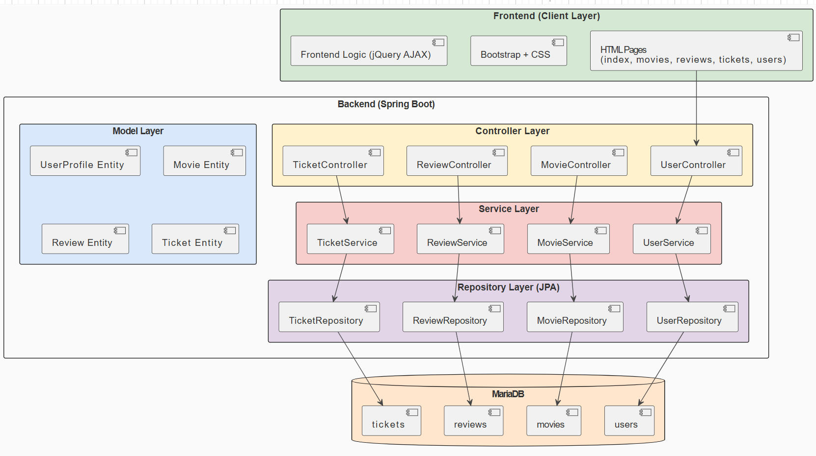

KEY WEBSITE FEATURES

Movie Reviews - Users can submit reviews for any movie, providing a written review text

User Profiles - Community members can create profiles with a username, email address, age, and a short bio. Email addresses are enforced as unique at the database level to prevent duplicate accounts.

Ticket Booking - Users can book tickets for a movie by entering a user ID, movie ID, showtime (date and time picker), and a seat number

REST API Backend - All four sections (movies, reviews, users, tickets) are powered by a fully separate REST API with complete CRUD support
Live Movie Search - The Movies page includes a real-time search bar that filters the movie table on every keystroke

DESIGN SUMMARY

Color Palette & Styling
The site uses a warm editorial aesthetic : a cream/parchment background (#F5F1E8) paired with deep crimson (#B22222) as the primary accent. This gives it a cinematic, premium feel distinct from typical blue/gray tech sites.
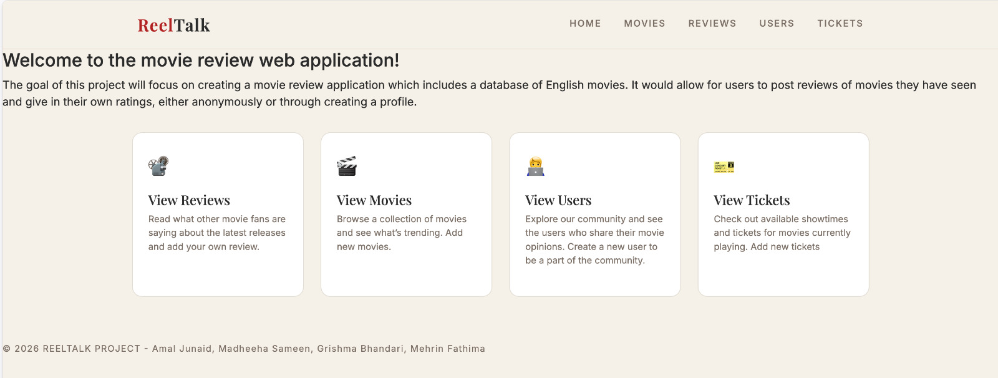
Typography
Two Google Fonts were chosen deliberately: Playfair Display (a classic serif) for page titles and the logo to evoke film posters and editorial design, and Inter (a clean geometric sans-serif) for all body text, labels, and UI controls
Navigation
A fixed top navbar with an effect stays visible while scrolling. Links are uppercase with letter-spacing for a refined look.
User interactions
All user interactions such as adding, editing, deleting, and searching are handled without page reloads using jQuery AJAX, giving the application a smooth single-page feel where the table updates instantly in response to every action.
Validation
Client-side form validation provides immediate feedback through browser alert dialogs when required fields are left empty or invalid values are entered, preventing incomplete data from being submitted to the backend

DATABASE DESIGN AND IMPLEMENTATION
Our project uses a database integrated as a persistent data store using MariaDB as the RDBMS. Connection to this persistent data store was configured in the application.properties file:
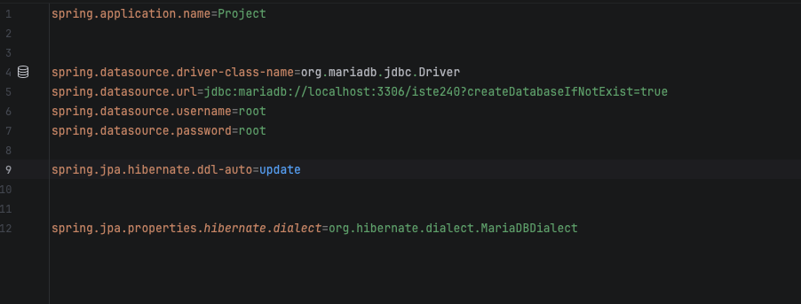
Note: setting spring.jpa.hibernate.ddl-auto to ‘update’ instead of ‘create’ allows for any data stored into the database to stay persistent and not reset once the application is stopped and rerun.

The database is named iste240 and includes 4 entities reflecting the 4 model classes in our project:
- movies(representing the Movie class)
- users(representing the UserProfile class)
- reviews(representing the Review class)
- tickets(representing the Ticket class)
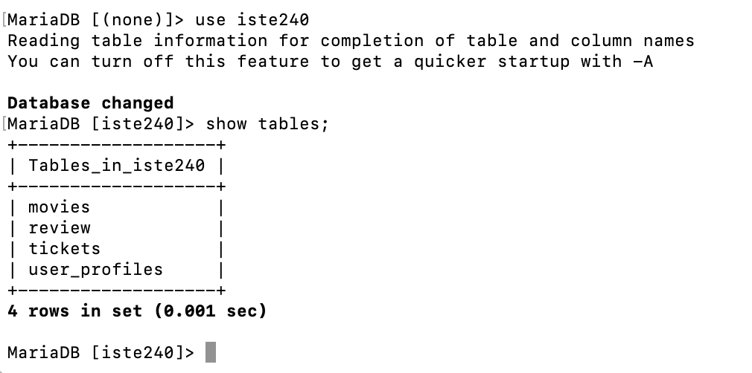

RELATIONSHIPS INVOLVED

Movies and users do NOT include fields for the reviews and tickets associated with them, but the reviews and tickets DO both include fields for movies and tickets, meaning that:
- reviews has a many to one relationship with movies (reviews can only be associated with one movie each, but many reviews can be associated with a single movie). The id field in movies serves as a foreign key in reviews.
- reviews also has a many to one relationship with users (each review can only be created by one user, but a user could create as many reviews as they like). The userId field in users serves as a foreign key in reviews.
- tickets has a many to one relationship with movies (each ticket can only be associated with one movie showing, but a single showing can have many tickets)The id field in movies serves as a foreign key in tickets.
- tickets also has a many to one relationship with users (each ticket can only be associated with one user but a single user can book many tickets). The userId field in users serves as a foreign key in tickets.
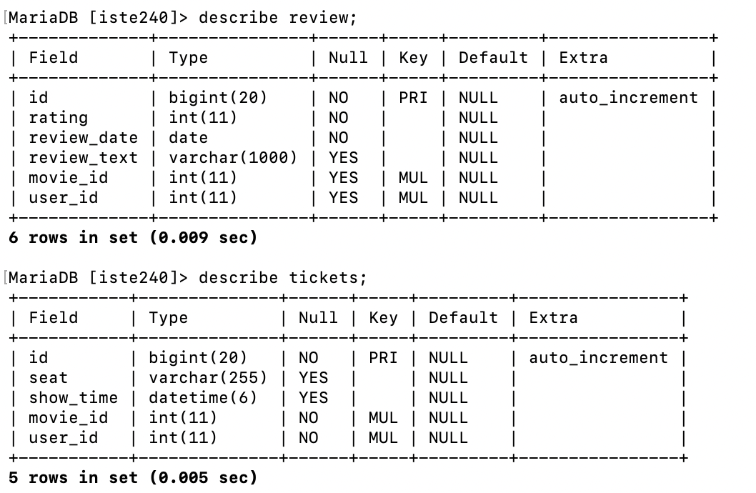
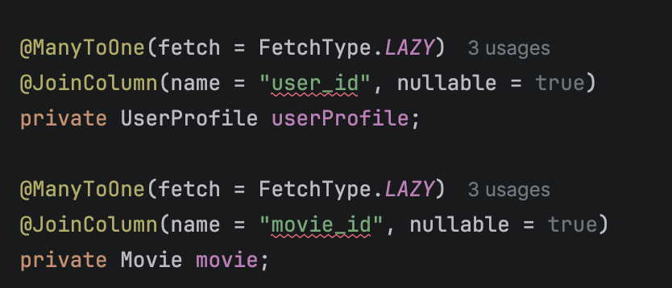

LOGICAL DIAGRAM
